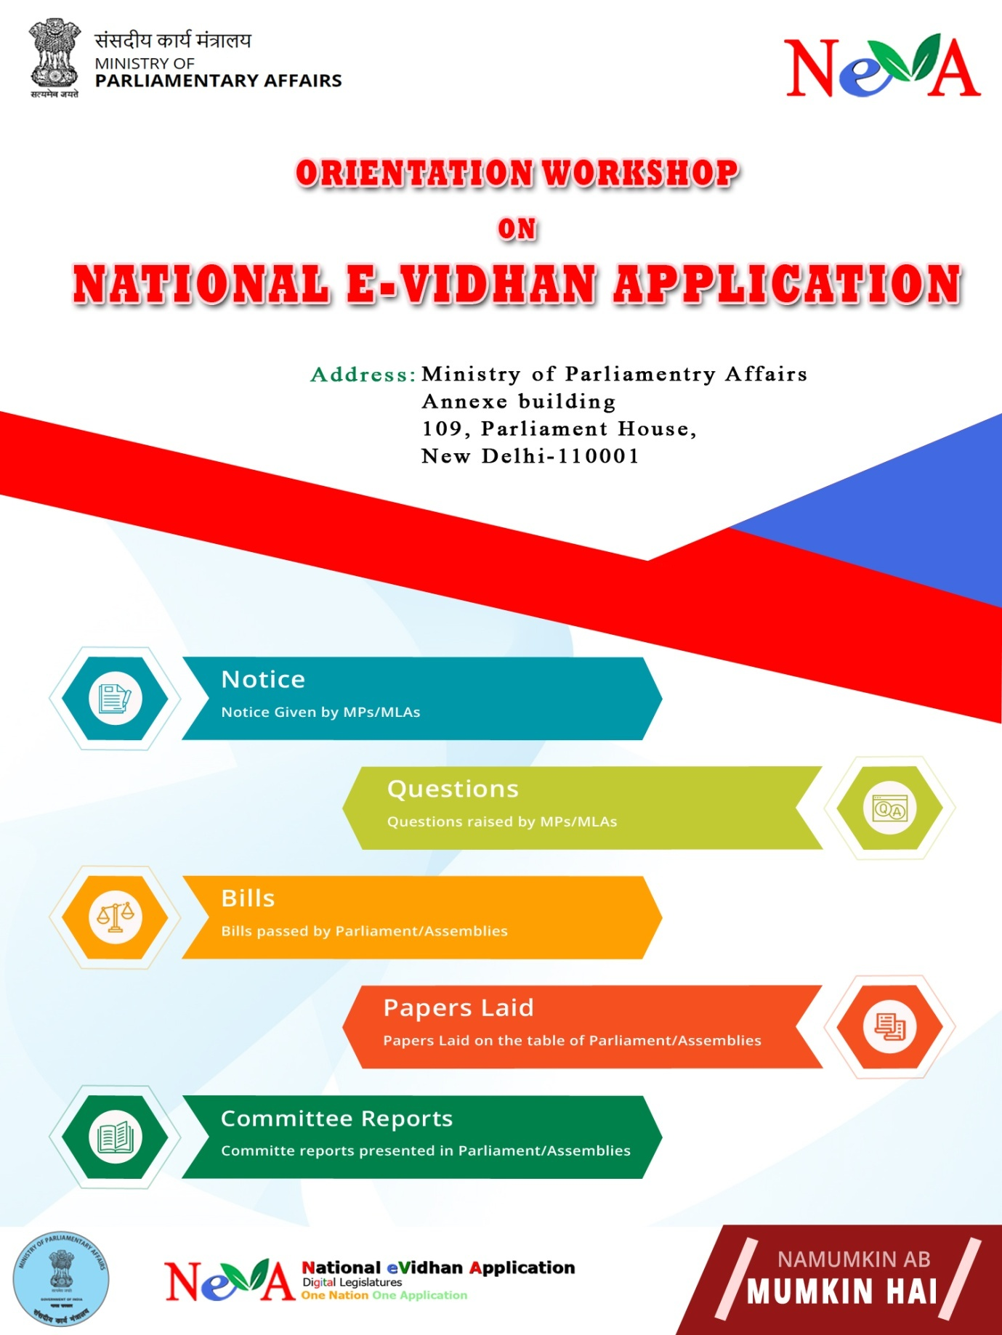

Brief Report on
Phase II Training Workshop on “National e-Vidhan Application (NeVA)” conducted at CPMU NeVA For Punjab Legislative Assembly
from 11th – 13th March, 2019

A three day Phase II Training Workshop on National eVidhan Application (NeVA) was organized at CPMU NeVA Parliament Annexe. The Workshop was organized by the Central Project Management Unit (CPMU) of Ministry of Parliamentary Affairs (MoPA), Government of India for Punjab Legislative Assembly Secretariat from 11th -13th March 2019.

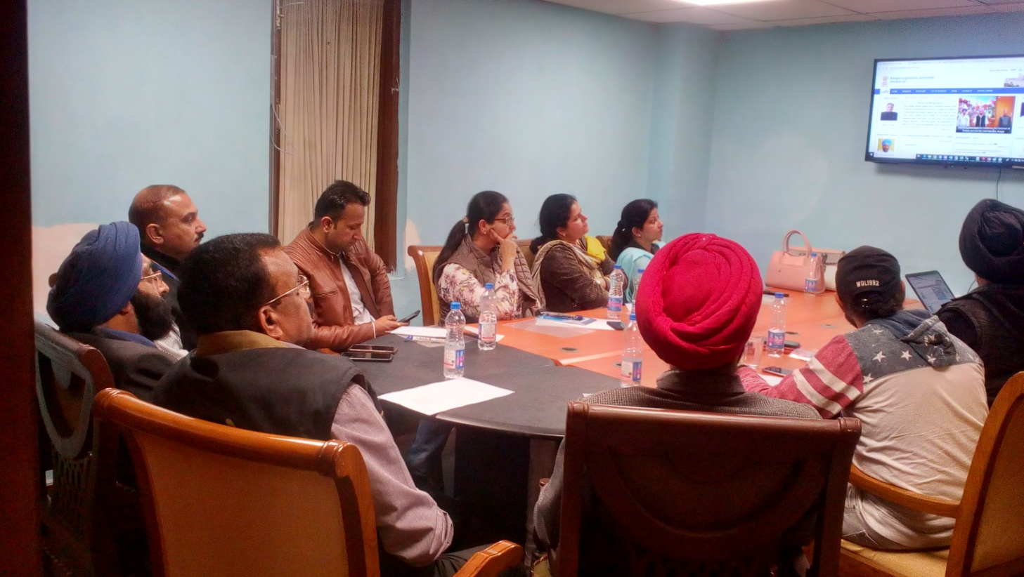

The inaugural session was attended by Shri N.S. Arneja, NIC, Government. of India, Shri Deepak Shirahatti, STD,NIC,Government of India, Shri S.K. Sinha STD,Government of India and participants from Punjab Legislative Assembly comprised various Nodal Officers and staff personnels wherein the latest redesigned version of NeVA application was briefed along with the future plans to propel this project by Shri N.S. Arneja .

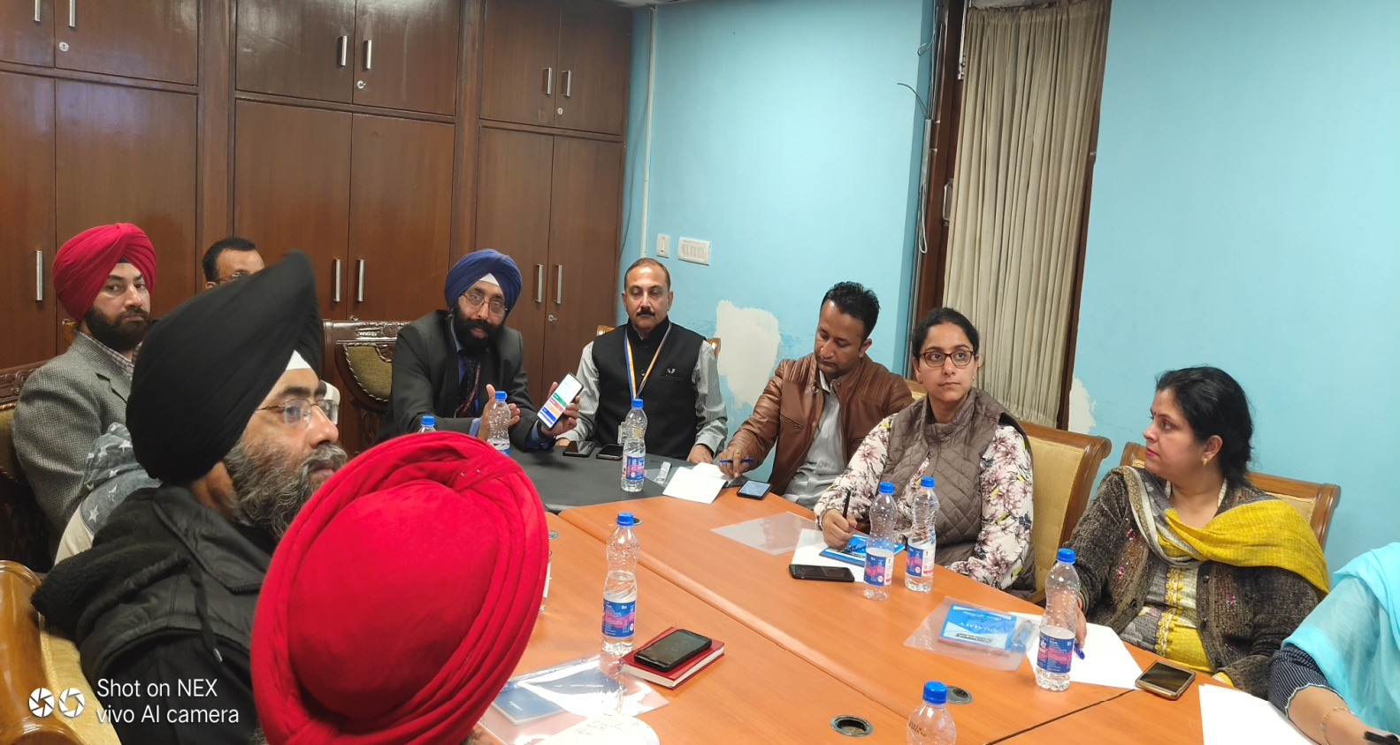

On the first day Shri Sujeet Kumar, NeVA Database Architect, as one of the resource persons from the Central Project Management Unit under Ministry of Parlimentary Affairs, Government of India, New Delhi gave a detailed account of the current updated version of NeVA with the new design and some of the latest incorporated functionalities in the software. Besides that , two technical sessions followed with a complete overview of the core functionality of the software application which included the modules like Master Data entry Module,Question Module, Department Module & LOB Module.

Shri Surendra Nath Tripathi, Secretary , MoPA, Government of India and Dr. Satya Prakash Khatana, Joint Secretary, MoPA, Government of India also attended an afternoon session wherein he appreciated the participants to evince tremendous level of zeal and cooperation in adopting the project and keeping up a great performance till date. Secretary, MoPA , discussed various issues confronting the officers and other personnels while working on the application and also encouraged the participants to come up with the suggestions or further ideas that would help in taking this project to the next orbit.
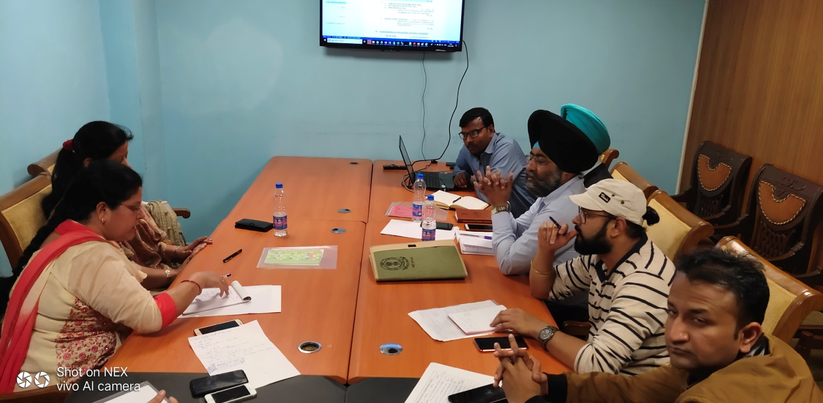

On the second and the third day of the workshop the participants were made to do extensive data entry apart from the work flow based question processing as well as the LOB generation through the web application with the help of Shri Sujeet Kumar, NeVA Database Architect ,Ms. Priyanka Barthwal, NeVA coordinator and other CPMU team members. During this hands on experience various issues faced by the participants were resolved as well as other technical queries were also noted down.

Shri Rana K.P. Singh, Hon’ble Speaker, Punjab Legislative Assembly has already shown a keen interest in computerization and digitization of Punjab Legislative Assembly and hasdesired to go ahead with NeVA project at the earliest so as to facilitate the Hon’ble Members of Punjab Legislative Assembly and public at large. In a concerted effort towards capacity building measures, the three day workshops are being conducted to familiarise more number of officials with the software who will be able to transfer knowledge further to the other officials and so on. Punjab is the first State across India to grasp the opportunity to get the workshop held in its Vidhan Sabha besides successful completion of the Phase II Training workshop at CPMU NeVA.

The valedictory session was presided over by Shri N.S. Arneja, NIC, Government. of India, Shri Deepak Shirahatti, STD,NIC,Government of India, Shri S.K. Sinha STD,Government of India, with the felicitation of the participants with the certificates of participation as a gesture of appreciation and encouragement .

